|  |  |  |  |  |
| --- | --- | --- | --- | --- |
| **Bug id** | **1** | **Bug name:** | | |
| **Steps to Reproduce:** | | Login Page: when log in with username **and** password that does not exist/invalid – 500 error appears | | |
| 1. Go to Paylocity benefits Login Page 2. Enter invalid or non-existing username (example: User 555) 3. Enter invalid password (example: 12345) 4. Click on “Log In” button | |
| **Project Name:** | Paylocity | |
| **Priority:** | High | |
| **Severity:** | Critical | |
| **Environment:** | Browser: Chrome, FireFox, Edge | |
| **Actual Result:** | | **Expected Result:** |
| System throws 500 error: An error occurred while processing your request.  Request ID: 0HMECHTJLL1LB  More details in attachment.  In development console of browser error is: https://wmxrwq14uc.execute-api.us-east-1.amazonaws.com/Prod/Account/Login 500 | | System should not throw 500 error, should stay on log in page and give a message like: “There were one or more problems that prevented you from logging in:  The Username field is invalid.  The Password field is invalid. Please try again” |

Attachments: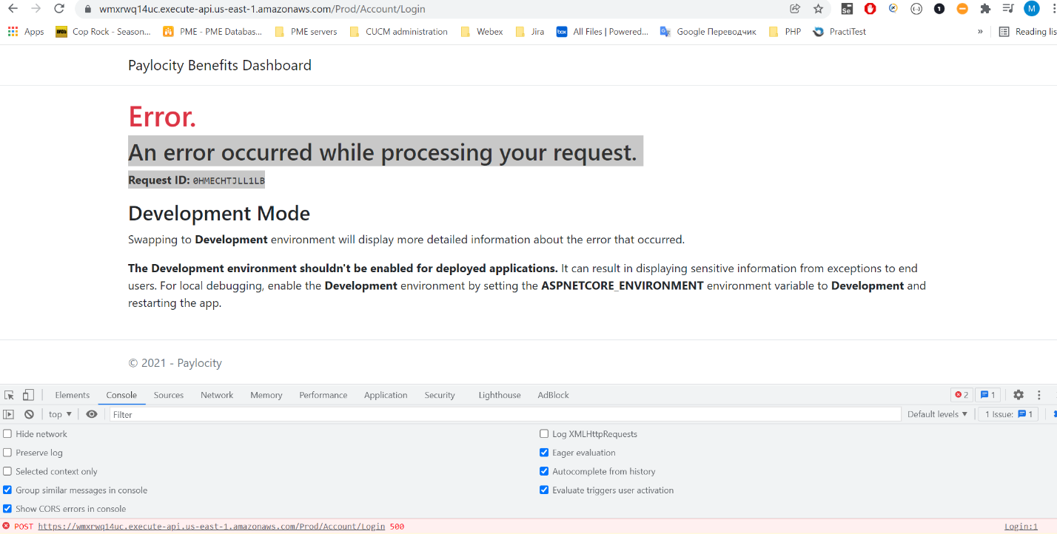

|  |  |  |  |  |
| --- | --- | --- | --- | --- |
| **Bug id** | **2** | **Bug name:** | | |
| **Steps to Reproduce:** | | Login Page: when user logs in, no user information is showing on dashboard | | |
| 1. Go to Paylocity benefits Login Page 2. Enter valid username credentials 3. Enter valid password 4. Click on “Log In” button | |
| **Project Name:** | Paylocity | |
| **Priority:** | Low | |
| **Severity:** | Low | |
| **Environment:** | Browser: Chrome, FireFox, Edge | |
| **Actual Result:** | | **Expected Result:** |
| System does not show username of a user who logged in, when have many users it will be difficult to define who was in the system and performed different types of actions. Most likely not a bug but a minor defect. | | System shows username/profile of a person who just logged in (typically in a right corner close to Log Out Button) |

|  |  |  |  |
| --- | --- | --- | --- |
| **Bug id** | **3** | **Bug name:** | |
| **Steps to Reproduce:** | | Login Page: when user did not log in the system and clicks on Paylocity Benefits Dashboard it gives an access to the page | |
| 1. Go to Paylocity benefits Login Page 2. Note: User should not be logged in to the system 3. Click on Paylocity Benefits Dashboard (heading in the upper left corner) | |
| **Project Name:** | Paylocity |
| **Priority:** | High |
| **Severity:** | Critical |
| **Environment:** | Browser: Chrome, FireFox, Edge |
| **Actual Result:** | **Expected Result:** |
| System refers to the Paylocity Benefits Dashboard (no existing data is showing) but able to see database existing columns (example: Dependents, Salary, Net Pay) and able to open the form “Add Employee” Console throws 403 error | System should not allow user to have any access to Paylocity Benefits Dashboard if they are not logged in the system with right credentials. Users should not be able to live login page and have access to any other pages if they are not logged in. |

Attachments:

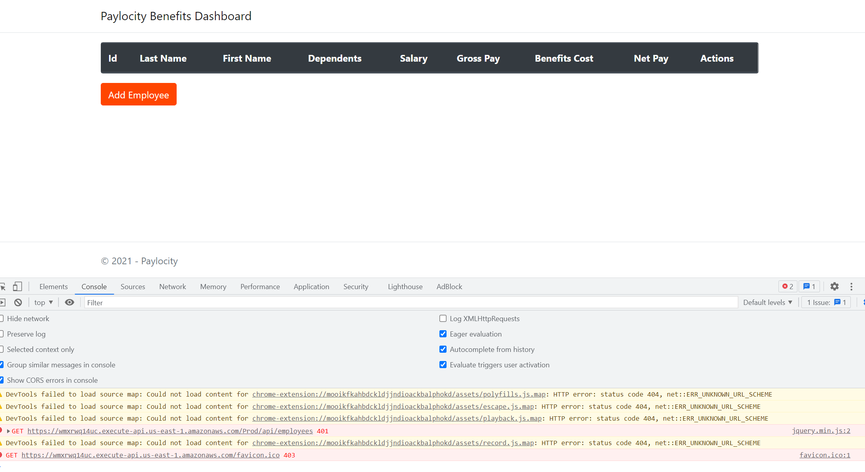

|  |  |  |  |  |
| --- | --- | --- | --- | --- |
| **Bug id** | **4** | **Bug name:** | | |
| **Steps to Reproduce:** | | Benefits Dashboard: When development console is open and logged user clicks on Reload page button – “Log out” button disappears and data from dashboard vanishes – system is breaking down. | | |
| 1. Go to Paylocity benefits Login Page 2. In your browser (example: Chrome) right click on a page and click Inspect. Then click on console tab. Do not close it. 3. Enter valid username and password 4. Click on “Log In” button 5. On the browser panel click on “Reload page” button or click on Benefits Dashboard Page header and page will reload automatically. 6. Repeat action from point 4 multiple times and check results. | |
| **Project Name:** | Paylocity | |
| **Priority:** | High | |
| **Severity:** | Critical | |
| **Environment:** | Browser: Chrome, FireFox, Edge | |
| **Actual Result:** | | **Expected Result:** |
| **Note:** bug is reproducible **only** when development console is **open**.  Every time when user clicks on Reload Page and Benefits Dashboard Page reloads – some elements are disappearing from the page (looks like the user is losing access to his profile and database). Unable to create new employee’s data.  Error in console: GET https://wmxrwq14uc.execute-api.us-east-1.amazonaws.com/Prod/api/employees 401  Attached screenshots:  Screenshot 1: when page reloads and user lost access to database entities  Screenshot 2: when page reloads and button Log Out disappears. | | Benefits Dashboard Page reloads multiple times and shows all existing data in columns and all buttons correctly whether dev console is open or closed. |

Attachments:

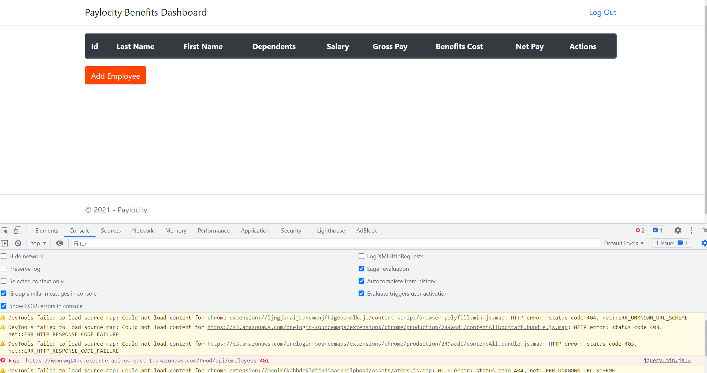

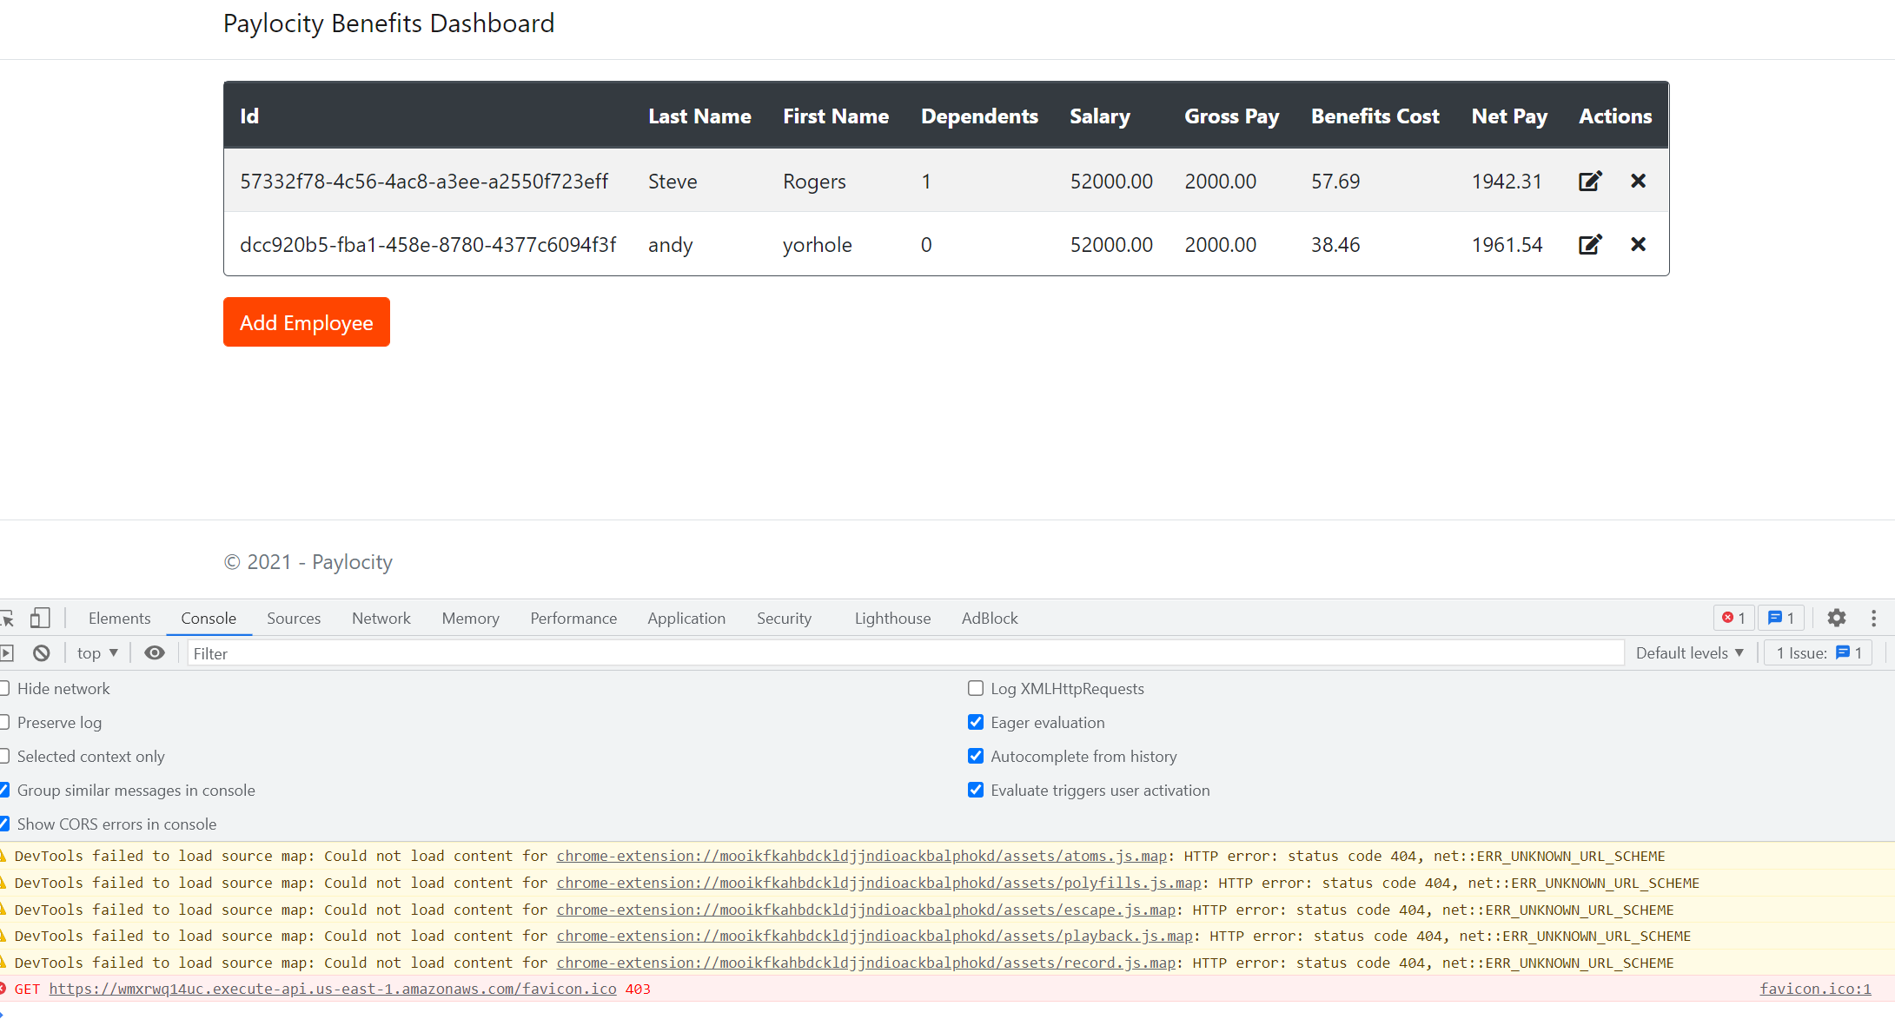

|  |  |  |  |  |
| --- | --- | --- | --- | --- |
| **Bug id** | **5** | **Bug name:** | | |
| **Steps to Reproduce:** | | Benefits Dashboard: Database IDs are showing in uuid format | | |
| 1. Go to Paylocity benefits Login Page 2. Enter valid username and password 3. Click on “Log In” button 4. If the database is clear - then create a new employee by clicking on Add Employee button and adding data in fields and saving the form. 5. Check the Id column in Dashboard. | |
| **Project Name:** | Paylocity | |
| **Priority:** | Medium | |
| **Severity:** | Medium | |
| **Environment:** | Browser: Chrome, FireFox, Edge | |
| **Actual Result:** | | **Expected Result:** |
| Ids of each employee on a Benefits Dashboard Page are shown in UUID format.  This column looks weird and unusual and takes a lot of place in a Dashboard Page | | Ids supposed to be shown in numerical format or either not to be shown at all in a Dashboard itself for better security. |

Attachments:

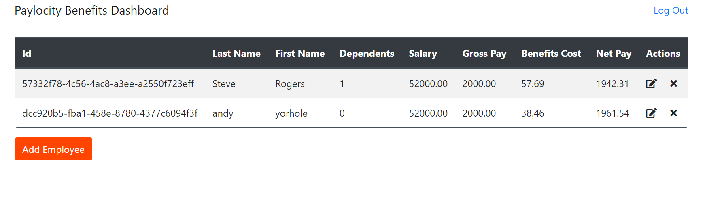

|  |  |  |  |  |
| --- | --- | --- | --- | --- |
| **Bug id** | **6** | **Bug name:** | | |
| **Steps to Reproduce:** | | Add Employee form: No Errors when user is trying to save blank employee form | | |
| 1. Go to Paylocity benefits Login Page 2. Enter valid username and password 3. Click on “Log In” button 4. Click on Add Employee Button (the form should open) 5. Do not fill any data and click on Add | |
| **Project Name:** | Paylocity | |
| **Priority:** | Low | |
| **Severity:** | Low | |
| **Environment:** | Browser: Chrome, FireFox, Edge | |
| **Actual Result:** | | **Expected Result:** |
| No errors appears when user hits Add button trying to save employee blank form.  400 Error in console: POST https://wmxrwq14uc.execute-api.us-east-1.amazonaws.com/Prod/api/employees 400 | | Error appears when user is trying to hit Add button when the form is blank. Error supposed to be like: “Please fill out all required data to add new employee”. |

|  |  |  |  |  |
| --- | --- | --- | --- | --- |
| **Bug id** | **7** | **Bug name:** | | |
| **Steps to Reproduce:** | | Add Employee form: No Errors when user is trying to save employee form with invalid input/data that exceeded limits. | | |
| 1. Go to Paylocity benefits Login Page 2. Enter valid username and password 3. Click on “Log In” button 4. Click on Add Employee Button (the form should open) 5. Fill out with data that exceeds limits (for Last and First names put data that is greater than 50 symbols; for dependents put number greater then 32 or some symbols) 6. Click Add | |
| **Project Name:** | Paylocity | |
| **Priority:** | Medium | |
| **Severity:** | Medium | |
| **Environment:** | Browser: Chrome, FireFox, Edge | |
| **Actual Result:** | | **Expected Result:** |
| No errors appears when user hits Add button and filling the form with invalid data/data that exceeds limits of symbols. Form does not being saved but no error is showing. The error in development console: https://wmxrwq14uc.execute-api.us-east-1.amazonaws.com/Prod/api/employees 500 | | Error appears when user is trying to hit Add button and filling the form with invalid data/data that exceeds limits of symbols. Error supposed to be like: “The data in following fields: {fields} invalid in exceeded limits. Please fill out valid data to add new employee”. |

Attachments:

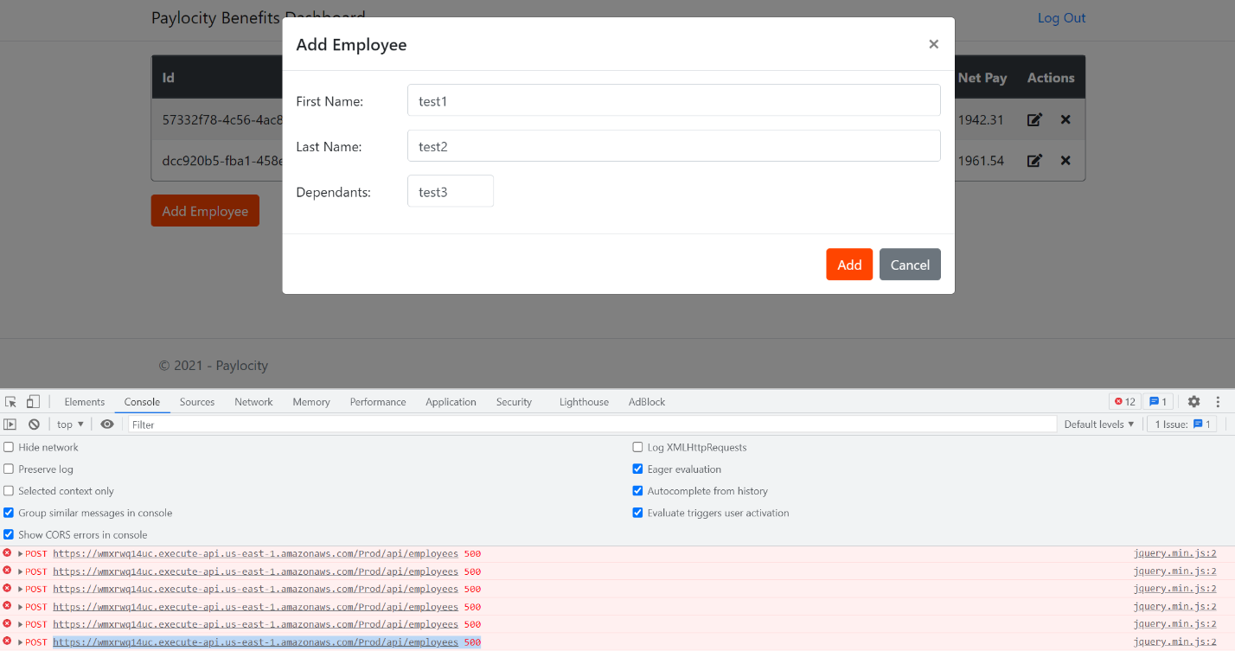

|  |  |  |  |  |
| --- | --- | --- | --- | --- |
| **Bug id** | **8** | **Bug name:** | | |
| **Steps to Reproduce:** | | API Update Employee request: When perform Update employee request - the new employee is being added with wrong Salary, Gross Pay, and Net Pay. | | |
| 1. Go to Postman 2. Open API Documentation 3. Click on “Log In” button 4. Open Update Employee request 5. Check that Authorization and Basic Token settings are set correctly 6. Check information in body ( by default it’s "id": "1945d706-39f3-49eb-bea8-98abcf766e5e",   "firstName": "Wanda",  "lastName": "Maximoff",  "dependants": 2)   1. Send the request 2. Check the results | |
| **Project Name:** | Paylocity | |
| **Priority:** | High | |
| **Severity:** | Critical | |
| **Environment:** | Browser: Chrome, FireFox, Edge | |
| **Actual Result:** | | **Expected Result:** |
| The new employee is being created in the system (instead of updating an existing one). The employee is being created with the new Id which is different from the one which was set in the request. Even though all the calculations are wrong (Salary, Gross Pay, and Net Pay).  The same employee can me created multiple times. | | If the Id exists in the system it should be updated with new data and all calculations of Salary, Gross Pay, Benefits and Net Pay should be correct according to dependents number.  If id does not exist in the system it should throw an error like : “cannot find user with existing id in the system, please try another one” |

Attachments:

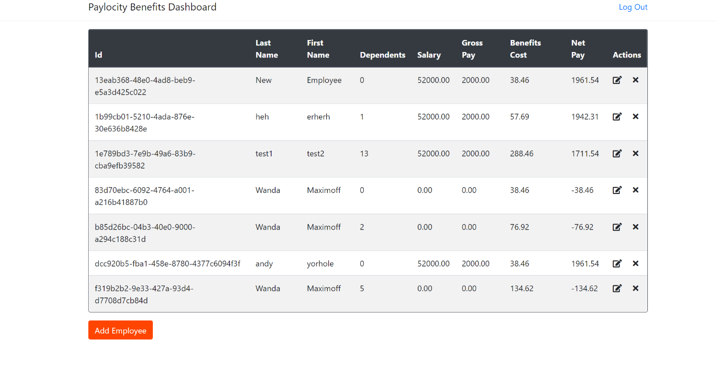

|  |  |  |  |  |
| --- | --- | --- | --- | --- |
| **Bug id** | **9** | **Bug name:** | | |
| **Steps to Reproduce:** | | API Delete Employee request: When perform Delete employee request – if the id of employee which user is trying to delete is non-existent – status of the request is 200 and no errors appears | | |
| 1. Go to Postman 2. Open API Documentation 3. Click on “Log In” button 4. Open Delete Employee request 5. Check that Authorization and Basic Token settings are set correctly 6. Put the Id in request which was not created in database(for example I used dcc920b5-fba1-458e-8780-4377c6094f3a) 7. Send the request 8. Check the results | |
| **Project Name:** | Paylocity | |
| **Priority:** | High | |
| **Severity:** | Critical | |
| **Environment:** | Browser: Chrome, FireFox, Edge | |
| **Actual Result:** | | **Expected Result:** |
| The status of request is 200 which and no response/errors in Postman Panel. It is incorrect because when id does not exist in database – employee cannot be deleted. | | The status of the request should not be 2**, supposed to be 4**. The system shows that request was performed, and employee was deleted but no employee was deleted because an Id is nonexistent. |

|  |  |  |  |  |
| --- | --- | --- | --- | --- |
| **Bug id** | **10** | **Bug name:** | | |
| **Steps to Reproduce:** | | API Get Employee request: When perform Get employee request – if the id of employee which user is trying to get is non-existent – status of the request is 200 and no errors appears | | |
| 1. Go to Postman 2. Open API Documentation 3. Click on “Log In” button 4. Open Get Employee request 5. Check that Authorization and Basic Token settings are set correctly 6. Put the Id in request which was not created in database(for example I used 1b99cb01-5210-4ada-876e-30e636b8428d) 7. Send the request 8. Check the results | |
| **Project Name:** | Paylocity | |
| **Priority:** | High | |
| **Severity:** | Critical | |
| **Environment:** | Browser: Chrome, FireFox, Edge | |
| **Actual Result:** | | **Expected Result:** |
| The status of request is 200 which and no response/errors in Postman Panel. It is incorrect because the id does not exist in database and employee data cannot be given. | | The status of the request should not be 2**, supposed to be 4**. The system shows that request was performed, and employee data should be shown in response but no employee is shown because an Id is nonexistent. |